Written by Tiffany Floyd

316 words

**Shaikhly, Ismail al-** (1924-2002)

Born in Baghdad, Iraq, Ismail al-Shaikhly was among the Baghdadi Institute of Fine Art’s first graduating class in 1945. At the institute, he studied under Faiq Hassan and is considered his most gifted student. After graduating from the Institute, al-Shaikhly travelled to Paris to attend the *Ècole Nationale Supérieure des Beaux-Arts.* Upon his return to Baghdad, al-Shaikhly became an active participant in several art groups that were gaining prominence in the 1950s and 60s. He was a member of the Pioneers and became the group’s leader in 1962. He was also a founding member of the Society of Iraqi Plastic Artists and participated in the Iraqi Artists Society. Al-Shaikhly exhibited extensively with these groups. He was also a prodigious exhibitor internationally. In 1955 and 1958, a collection of his works toured countries like China, Russia, Bulgaria, Poland, and India. Early in al-Shaikhly’s career his work borrowed much from his mentor Faiq Hassan. However, he soon developed his own interpretation of subject matter favored by many of his contemporaries, the environs and people of Iraq. The painter is best known for his feminine masses composed of color and ovular shapes. These female figures, recognizable by the abaya, cluster together with emotional energy. The power of al-Shaikhly’s representations is intertwined with this rhythmic energy. It suggests not only the colors and forms of everyday Iraqi life but also the essence of its experience.

**References and further reading**:

Ali, Wijdan. *Modern Islamic Art: Development and Continuity*. Gainsville: Florida University

Press, 1997.

**Faraj, Maysaloun, ed.** ***Strokes of genius: Contemporary Iraqi art*.** London: Saqi Books, 2001.

Mudaffar, May. “Iraq” in *Contemporary Art from the Islamic World*, edited by Wijdan Ali.

Amman: The Royal Society of Fine Arts, Essex, England: Scorpion Publishing, 1989.

Pocock, Charles. *Modern Iraqi Art: A Collection*. Dubai: Meem Gallery, 2013.

Saad, Qassim. "Contemporary Iraqi Art: Origins and Development." *Scope: Contemporary*

*Research Topics* (Art & Design, 2008) 3, 50-54.

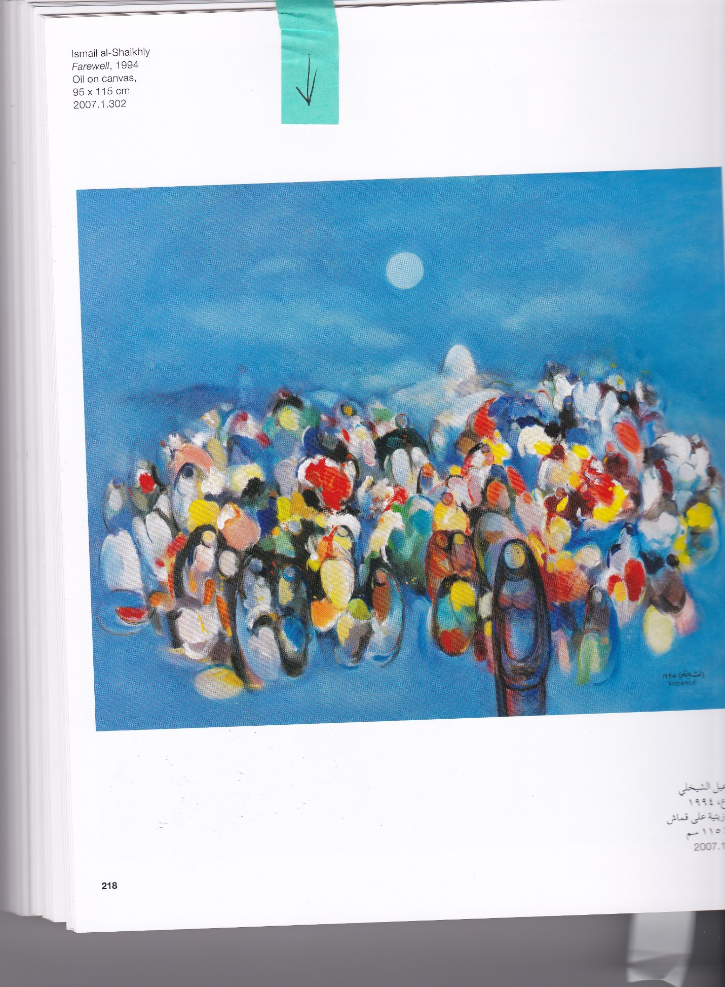

Ismail al-Shaikhly

*Farewell*, 1994

Oil on canvas

95 x 115 cm

Mathaf: Arab Museum of Modern Art